# User manual

1. 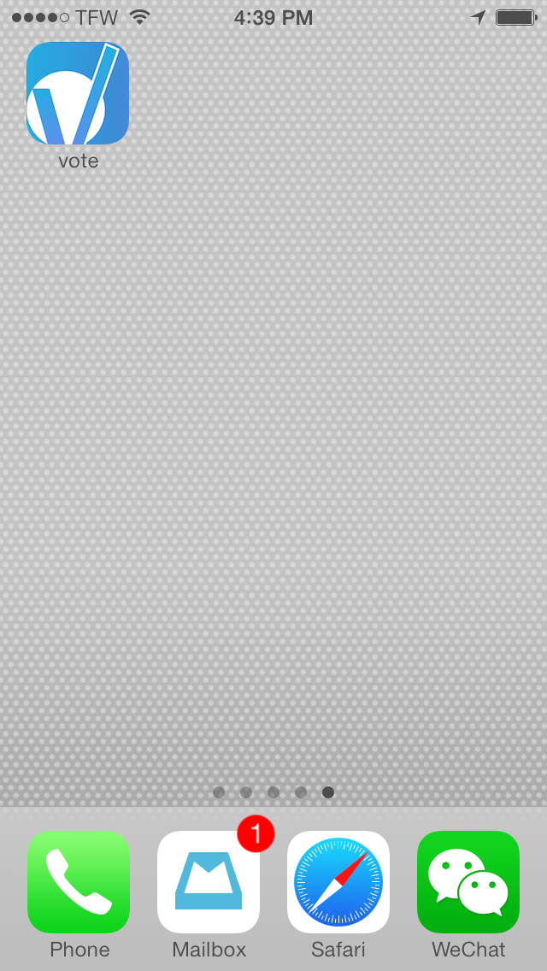Tap on the application icon to enter into the application

2.If this application were first being launched, it would ask users to sign up or sign in with their existing account. Here, I will show the screen shots of steps that users should take when they sign up.

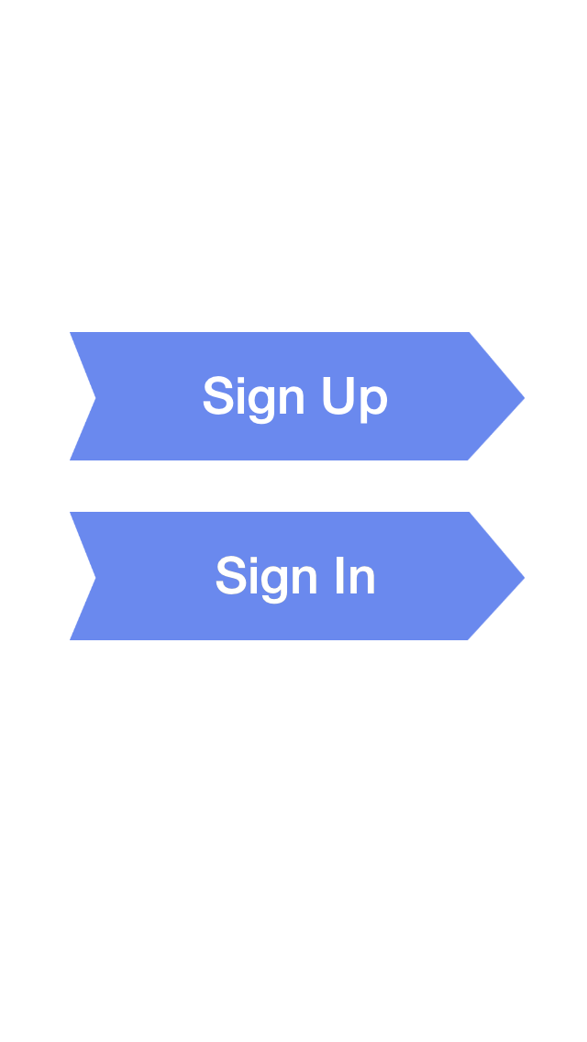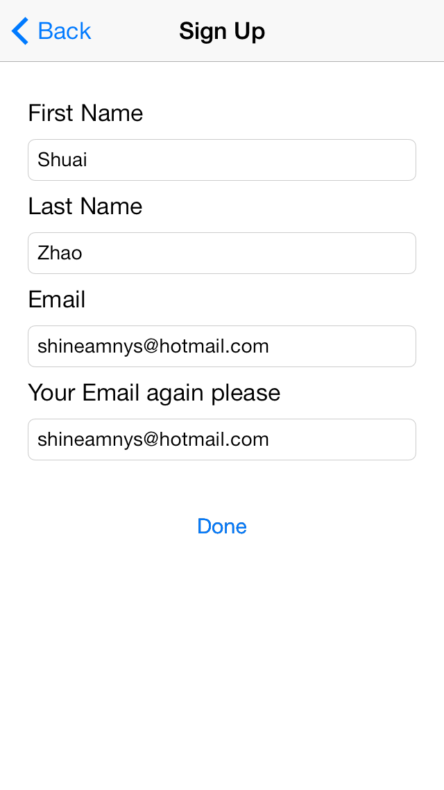

If you enter the correct information without leaving any blanks or entering different email addresses, users could see the next page that ask you to type in verification code, which would be sent to your email box that you just give.

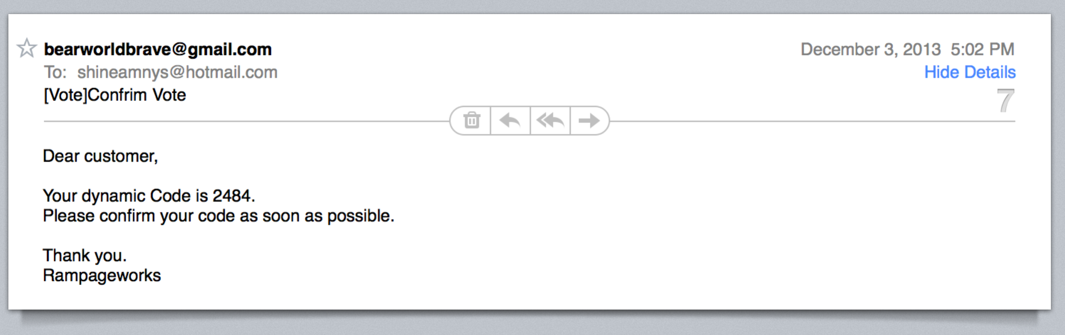

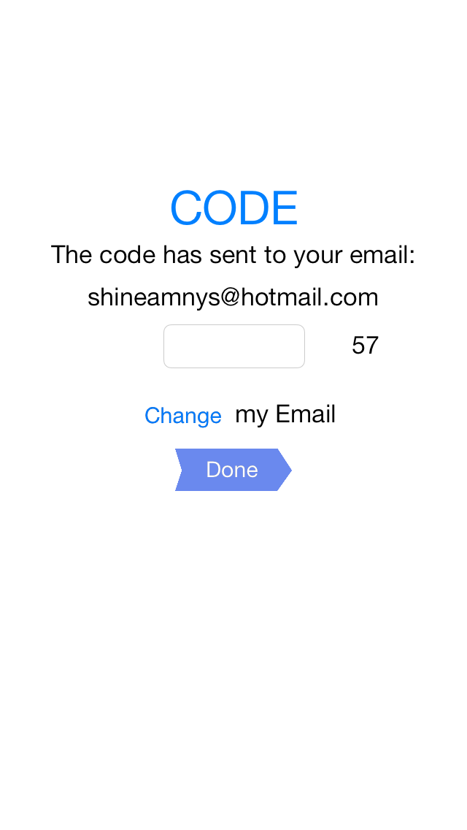

If users type in the correct code, they could successfully sign in. Of course, after that, users could initiate a vote. Users should take six steps to finish initiating a vote. First step: users could choose the color of this vote event, which would help other people to differentiate your vote from others.

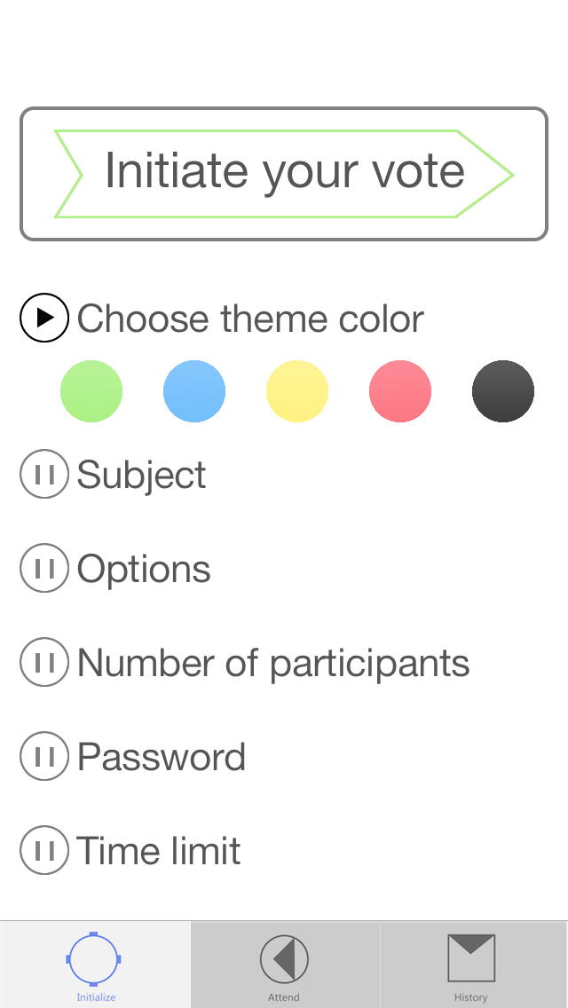

Second step: users could enter the subject of this vote.

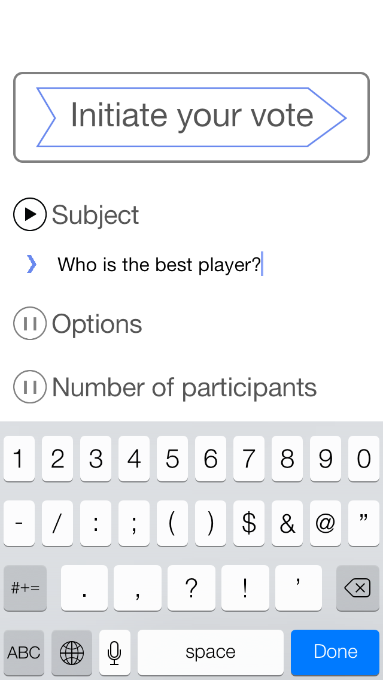

Third step: users could type in the choices they want to have. If you want more choices, you could just tap on “add an option”.

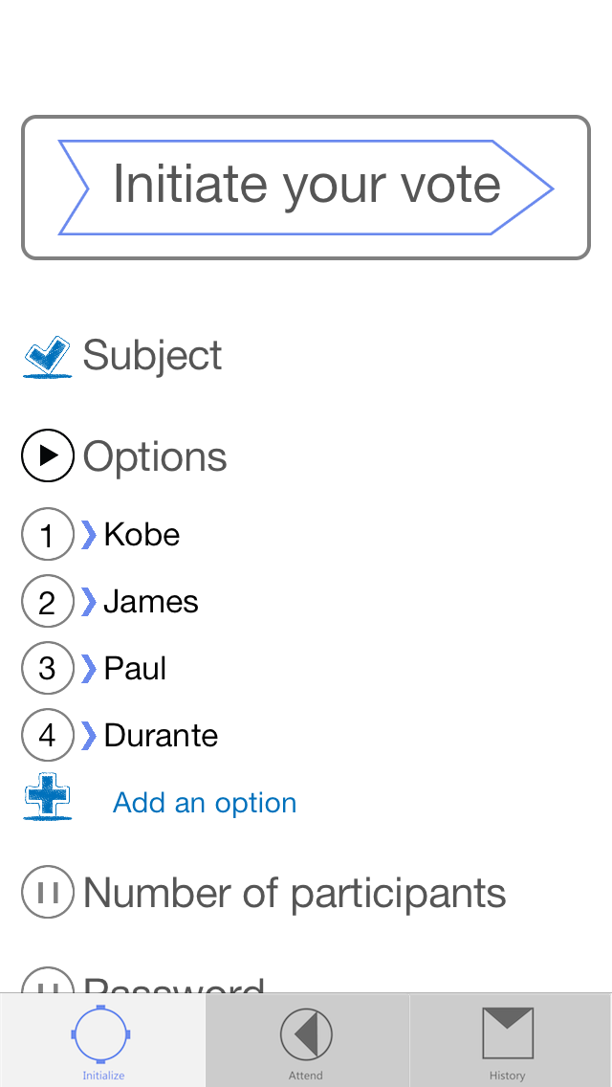

When users have entered the choices, they could also delete any one if they want.

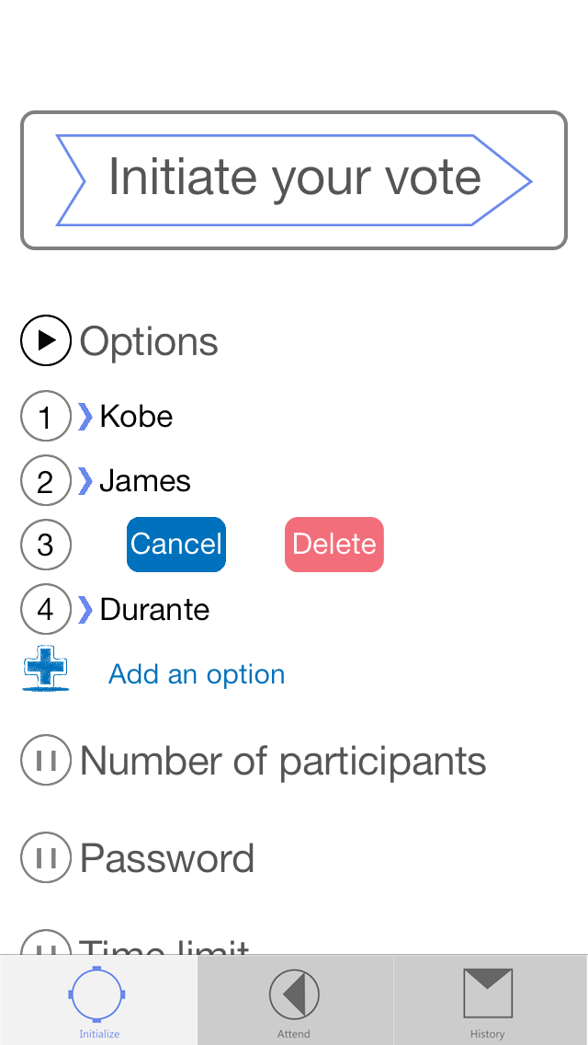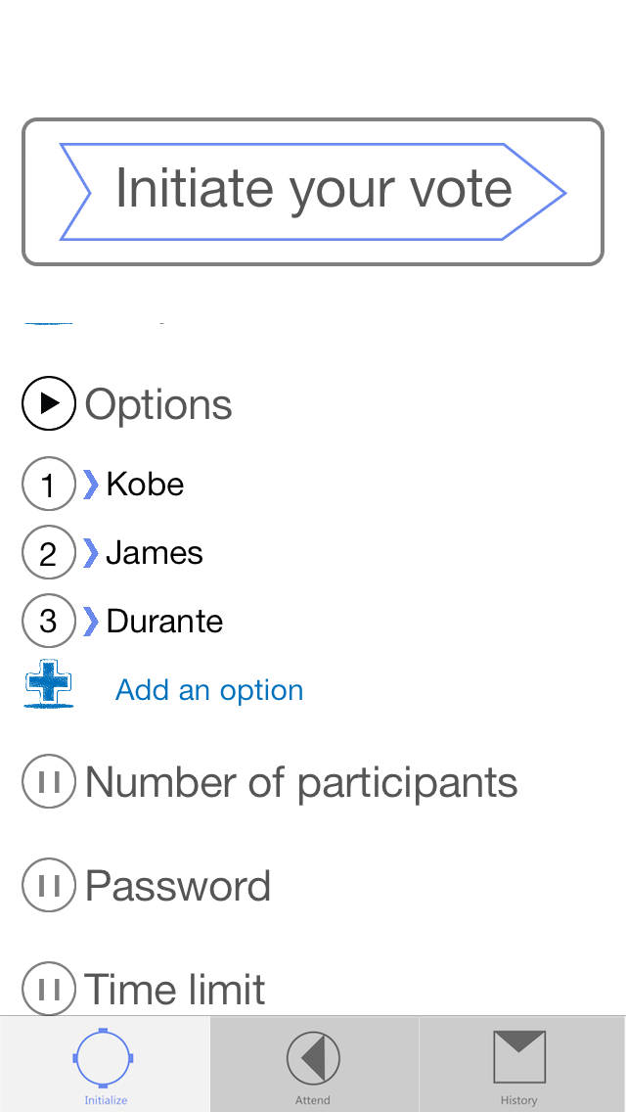

Fourth step: users could type in the number of whole participants.

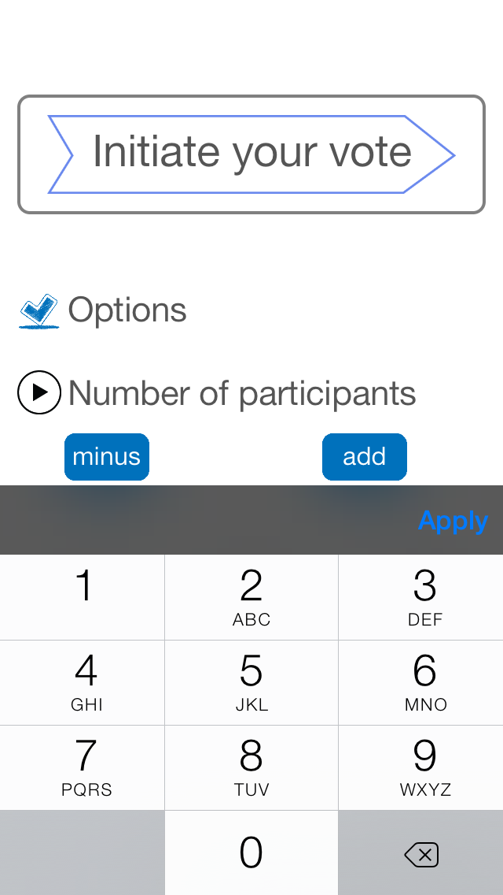

Fifth step: Users should set up a password for this vote event so that people should have password to participate this vote event.

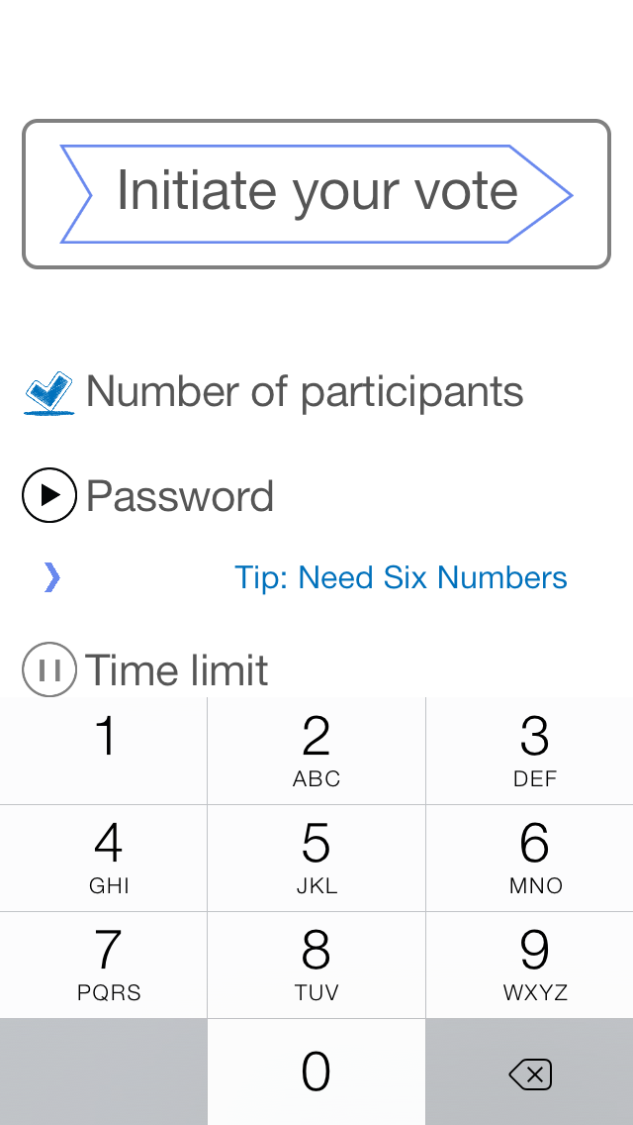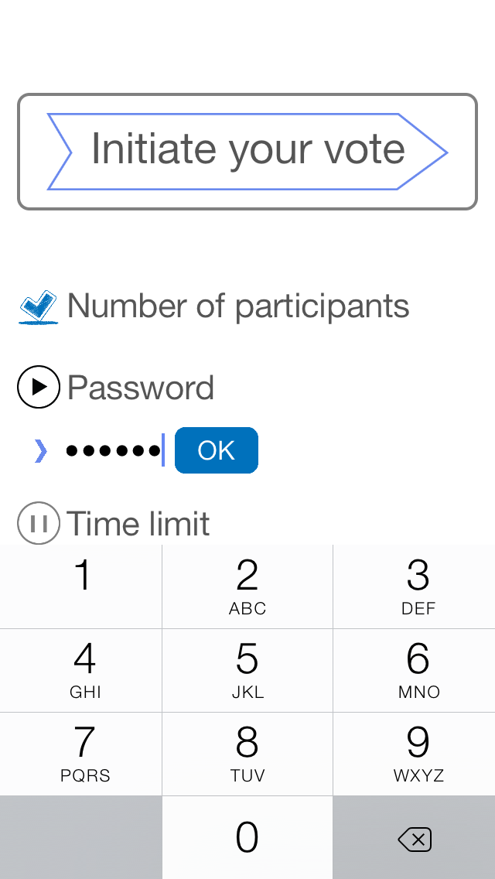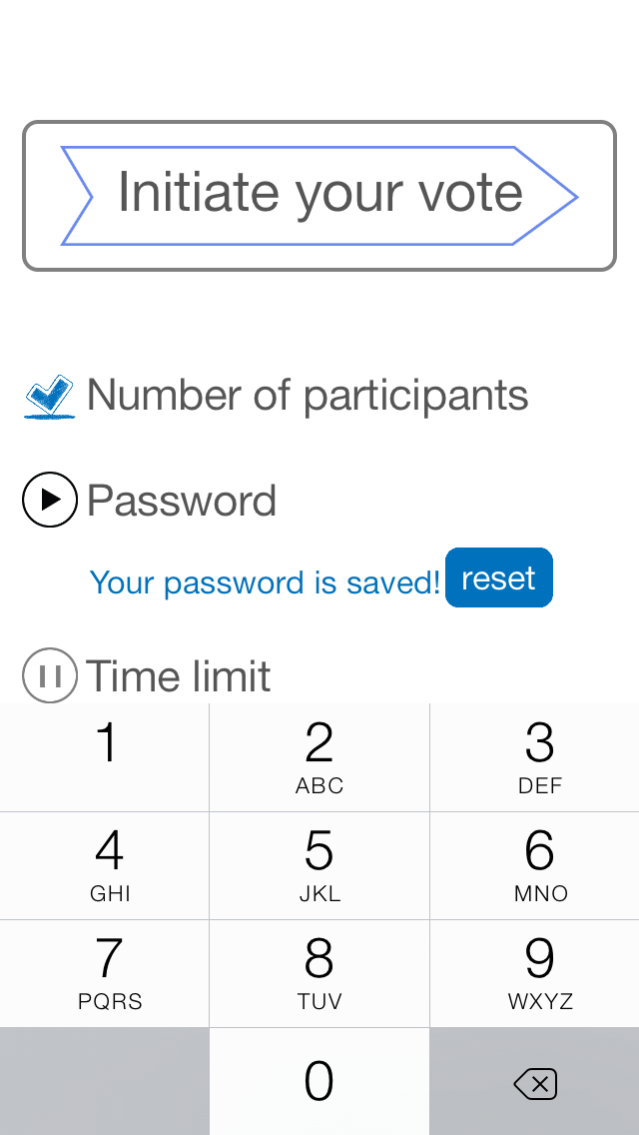

Last step: Users should give a time limit to this vote. By doing so, every participant have to vote within limited time.

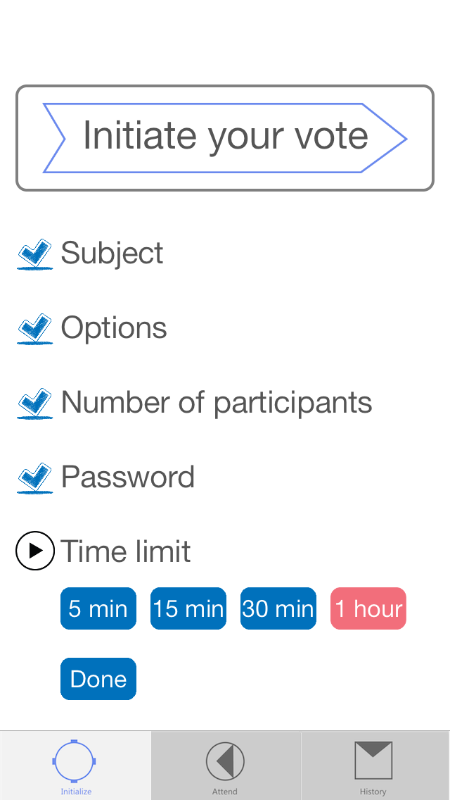

After all steps have finished, the “done” button would show up. Users could press this button to initiate this vote event. And the location information would be automatically stored on this vote event.

If users tap on the “attend” button on the tab bar that is on the bottom of the screen, they could find any vote event within 1000 meters.

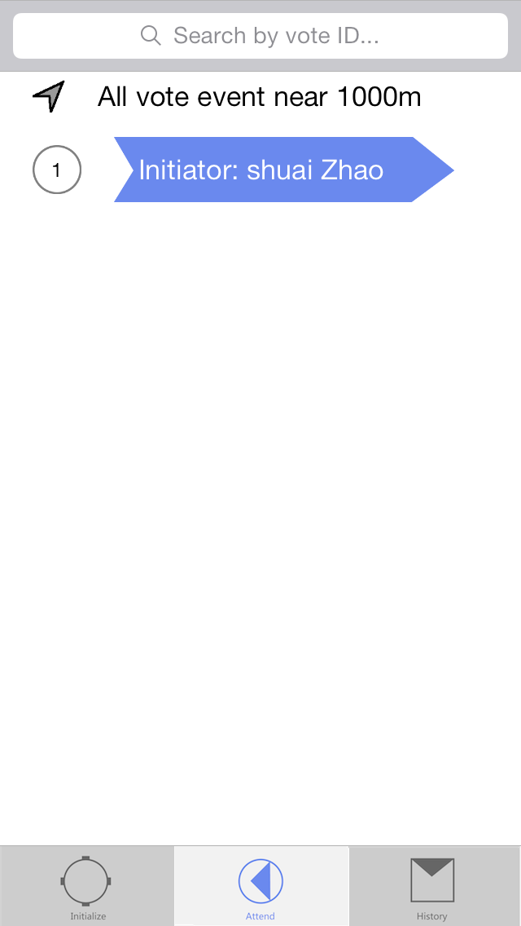

When the participant gets the password of the vote event you are asked to attend, they could tap on the event they have found to enter in.

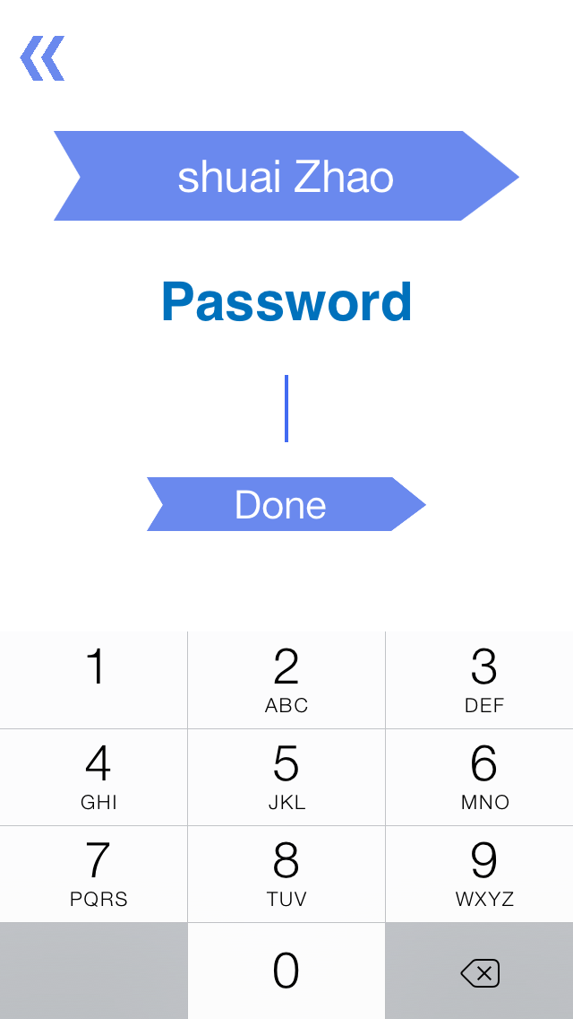

After participants successfully enter into the vote event, they could just tap on the option they want to choose.

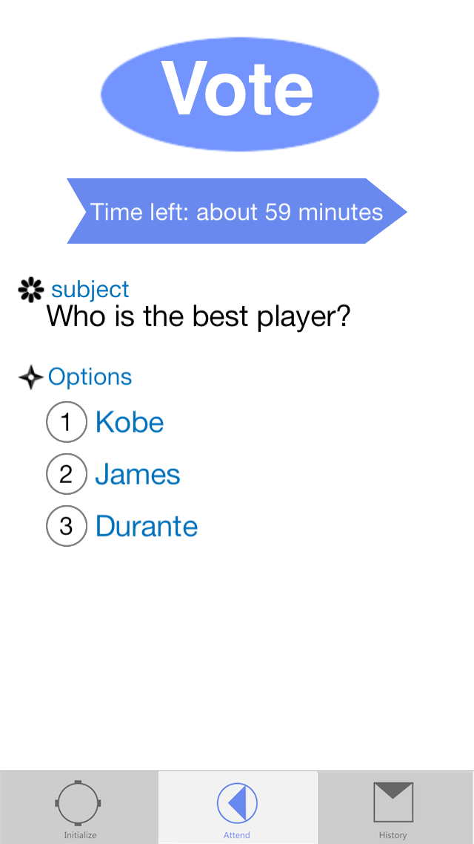

If I type on the first choice, the page would be showed like the following screen shot.

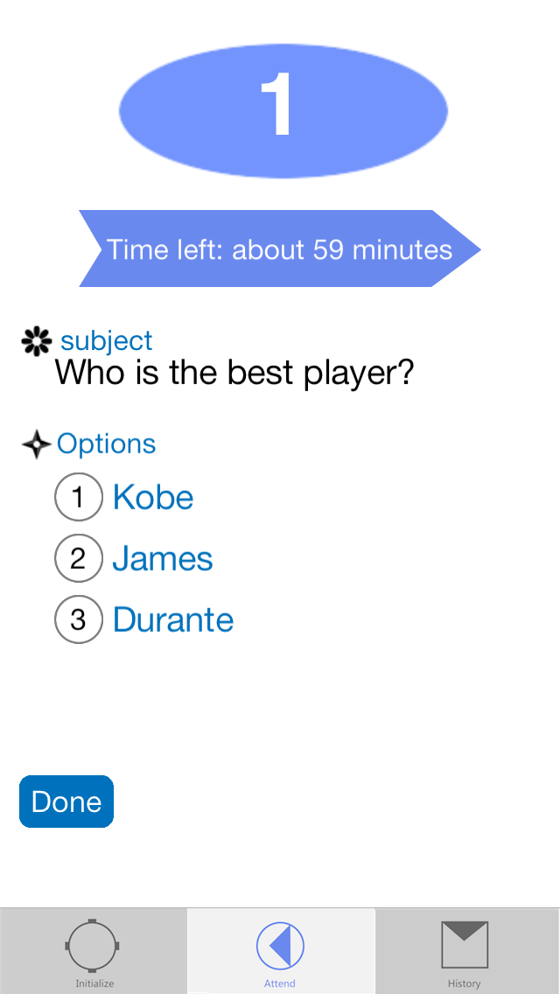

Finally, let me talk about the history part of this application. When you tap on the “History” button on the tab bar, you could see the “history” page. Of course, you could see the vote you attended or you initiated.

